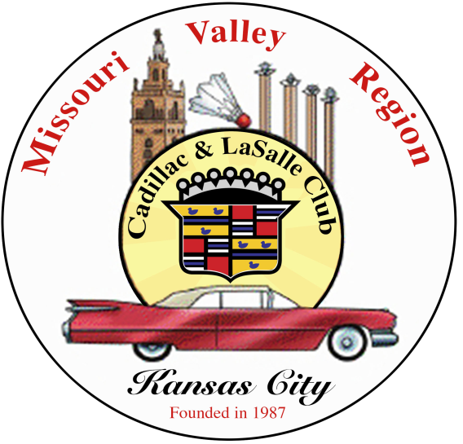
Missouri Valley Region Cadillac & LaSalle Club
May, 2026 Monthly Meeting

Your Classic Ride
2711 Warwick Trafficway
Kansas City, MO 64108

May 17, 2026 Meeting Minutes

1. Call to Order - the meeting was called to order by Co-presidents Guy Teel and Randall Penn

2. Recognition

a. Guests – None
b. New Members Present – None
c. Birthday Congratulations: May 15 – Cynthia Eisenhauer, July 21 – Mita Hoaglund
d. Anniversary Congratulations: June 16 – Cindy & Guy Teel, July 20 – Cynthia & Larry Eisenhauer

3. Minutes of Last Meeting - Minutes of the April meeting were distributed and accepted.

4. Treasures Report - Treasurer, Paul Williamson, reported

Previous Balance of $14,669.46
Club Income: $150.00 for Dues
Club Expenses: 0
Current Balance of $14,819.46

5. New Business

a. Website: Website link – https://kccadillacclub.org
Associated Car Clubs of KC Event Finder link - https://kansascityautomuseum.com/event-finder/

b. Activities' Update by Tom Keegan

Wednesday, June 10, 4:30 PM
Abdallah Shrine 2026 Car Rodeo Cruise
Johnson County Fairgrounds

Saturday, June 13, 10:00 AM
Spring Drive
Start at Linda Hall Library

c. Midwest Dream Car Collection Club Member & Route 66 Expert, Doug Meloan is the Operation Manager and Curator of this prestigious Manhattan, Kansas automobile museum. Doug encourages members to visit anytime. For upcoming event info visit - https://midwestdreamcarcollection.org

d. Online / Virtual Club Meetings: was suggested to expand participation to those who can’t travel to the meetings. Let Co-president, Randall Penn know if you are interested in helping to launch this project.

e. Members’ Volunteer Opportunities:
Create the Club Newsletter
Invite a Guest Speaker to the Club Monthly Meeting
Arrange a Club Activity
Organize the Holiday Gathering

f. 2027 Overnight Driving Excursion to Arkansas or Nebraska: Steve Christensen suggested a Club tour of the Museum of American Speed, 599 Oakcreek Dr. Lincoln, Nebraska 68528 and the Strategic Air Command & Aerospace Museum, Ashland, Nebraska 68003. Guy Teel suggested a Club tour of Erik Miner’s father’s private classic car collection and his ice cream shop in Bella Vista, Arkansas, along with the Crystal Bridges Museum of American Art, 600 Museum Way, Bentonville, Arkansas 72712.

6. Old Business

a. Kansas City Automotive Museum Please consider supporting and visiting this nonprofit venue that serves all in the greater Kansas City area. They host a wide variety of activities to support the car collectors’ community. A couple of Club members volunteer as docents at the museum. Exciting News - the museum has collected over 2/3rds of monies needed to build their new facility. Donations are always welcome!

b. Monthly Meeting Location - When not tied to an event, monthly Club meetings will be held at Your Classic Ride, 2711 Warwick Trafficway, KC,MO. 64108 .Please check the Club website - https://kccadillacclub.org and your email for updated Club meeting information.

c. New Member Drive
Club logo pens and printed, local and national, Club applications will be distributed to prospective new members at events. Continue to represent the Club with signage and an information table at events.

d. Local Club Dues
Local, Missouri Valley Region – KC Cadillac Club annual dues of $20.00 are to be paid every January.

7. Other Business

2026 Grand National Meet – June 1-6,
Embassy Suites by Hilton Charlotte Concord Golf Resort & Spa, Concord, North Carolina

2026 Cadillac Fall Festival – September 25-26
Gilmore Car Museum, Hickory Corners, Michigan

2026 National Driving Tour – October 13-17
Rocket City Rendezvous
Huntsville, Alabama

8. Next Meeting – June 13th at ~3:00

Anita B. Gorman
4750 Troost Ave.
Kansas City, MO 64110

9. Adjourn - with no other business to transact, the meeting was adjourned.

